Architecture Document
System Diagram:
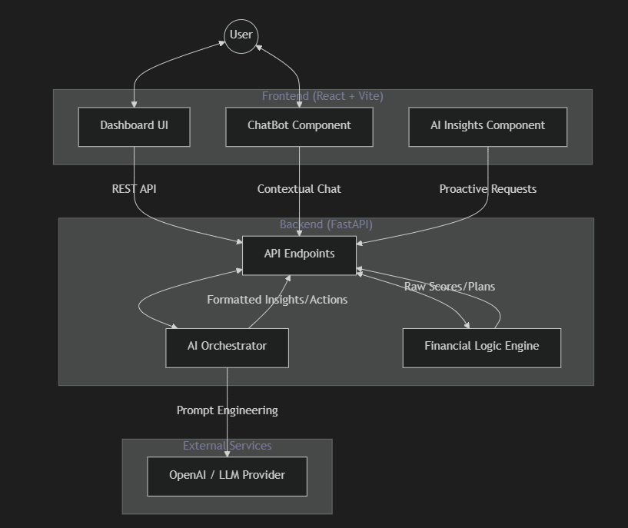

Agent Roles & Responsibilities
The system employs several specialized "agentic" roles to provide a cohesive financial mentoring experience:

Role | Responsibility | Implementation
Conversational Mentor | Handles free-form user queries, grounded in the user's current financial data. | ChatBot.tsx + /chat endpoint
Insight Generator | Periodically analyzes financial scores and gaps to produce proactive advice. | AIInsights.tsx + /ai-insights
Action Strategist | Synthesizes complex profile data into 2 high-impact "next moves". | /ai-actions endpoint
Risk Profiler | Analyzes qualitative user input (goals/fears) to determine risk tolerance. | /risk-profile endpoint

Communication Flow
- Direct Interaction: The user enters data in the Dashboard UI.
- Engine Calculation: The UI sends raw data to the Financial Logic Engine. It returns deterministic results (Wealth Health Grade, FIRE Gap, Tax Comparison).
- Contextual Enrichment:
- Deterministic results + User profile are bundled into a prompt for the AI Orchestrator.
- The Orchestrator communicates with the LLM Provider to generate qualitative insights.
- Feedback Loop: The ChatBot maintains state by sending the session's financial context to the backend with every message, ensuring the AI "knows" what the user is looking at.

Tool & Technology Integrations
- FastAPI: High-performance backend hosting RESTful endpoints.
- OpenAI SDK: Interface for qualitative AI reasoning and natural language processing.
- Financial Logic (logic.py): A standalone module for Indian tax laws and retirement math.
- Tailwind CSS: Modern styling system with a custom premium monochrome theme.
- Lucide React: Comprehensive icon library for financial entities (Wallets, Shields, Charts).
- Recharts: SVG-based charting library for data visualization.

Error Handling Logic
To ensure a "fail-safe" user experience, the system implements tiered error handling:

- API Level: All endpoints are wrapped in try-except blocks. In case of unexpected failures, standard HTTP 500 exceptions are raised with descriptive details.
- AI Fallbacks:
- If the LLM is down or unreachable, the backend returns pre-defined fallback insights and actions based on basic heuristics.
- Regex-based JSON extraction is used to sanitize LLM responses before parsing, preventing "unstructured text" crashes.
- Frontend Resilience:
- Loading states (skeleton screens or spinners) prevent interaction during slow AI generations.
- Optional chaining and default states handle cases where the backend might return incomplete data.
- Environment Validation: The system detects missing API keys and provides "Offline Mode" warnings instead of crashing.

Impact Model

1. Executive Summary
Category | Estimated Impact (Annual) | Primary Driver
Time Saved | 13 - 18 Hours | Automated data synthesis & reporting
Cost Reduced | ₹35,000 - ₹65,000 | Tax regime optimization & deduction discovery
Wealth Gained | 1.5% - 3.0% Alpha | Optimized asset allocation & risk profiling

2. Core Assumptions
To quantify these metrics, we assume a "Standard Target User" profile:
- Profile: Mid-level salaried professional in India.
- Annual Income: ₹20,00,000 (INR 20 Lakhs).
- Existing Habits: Manual tracking via spreadsheets or disparate apps.
- Investment Portfolio: ₹10,00,000 (INR 10 Lakhs) across various assets.
- Hourly Value: ₹1,200 (approx. ₹2.5L/month salary basis).
3. Quantified Impact Breakdown
A. Time Saved (Productivity Impact)
Manual financial planning involves gathering bank statements, calculating tax liabilities across regimes, and projecting retirement math.
- Manual Effort: ~20 hours/year (1.5 hrs/month + 2 hrs for tax season).
- Money Mentor AI: ~3 hours/year (Real-time dashboard + AI chat).
- Net Savings: 17 Hours/Year.
- Economic Value: 17 hrs × ₹1,200/hr = ₹20,400 productivity gain.
B. Cost Reduced (Tax Optimization)
Many users fail to optimize between the Old and New tax regimes or miss specific deductions like Section 80D (Health Insurance) or 80CCD(1B) (NPS).
- The Problem: 65% of professionals overpay tax by ₹20k - ₹40k due to sub-optimal regime choice.
- AI Intervention: The "Tax Wizard" uses the Logic Engine to provide a mathematically perfect comparison.
- Estimated Savings: ₹35,000/year (Average conservative estimate for ₹20L bracket).
C. Revenue Recovered (Wealth Generation)
The "AI Risk Profiler" and "Allocation Overview" identify "lazy capital" (excessive cash in savings accounts) and move it toward higher-yielding assets.
- Scenario: Shifting ₹2,00,000 from a 3.5% Savings Account to a 12% Index Fund.
- Yield Differential: 8.5% improvement.
- Annual Gain: ₹17,000 (Direct wealth recovery from inflation decay).
- Portfolio Alpha: A 2% improvement in total portfolio allocation on ₹10L = ₹20,000/year.
4. Back-of-the-Envelope Math (Total Value)
For a single user, the Total Annual Value Realized (TAVR) is:

₹20,400 (Time) + ₹35,000 (Tax) + ₹20,000 (Wealth) = ₹75,400 / Year

Scalability Logic
If deployed as an employee benefit in a 1,000-person organization:
- Total Corporate Productivity Reclaimed: 17,000 Hours (~8.5 Full-Time Employees).
- Total Financial Wellness Delivered: ₹75,400,000 (₹7.54 Crores) in aggregate retirement and tax benefits.
5. Risk & Error-Handling Adjustments
To remain realistic, we apply a 20% "Reality Buffer" to account for:
- User implementation gap (receiving advice but not acting on it).
- Market volatility affecting wealth gain projections.

